UNIT – 9
CLASSES IN PYTHON
Python is an object oriented programming language. Unlike procedure oriented programming, where the main emphasis is on functions, object oriented programming stresses on objects.
An object is simply a collection of data (variables) and methods (functions) that act on those data. Similarly, a class is a blueprint for that object.
We can think of class as a sketch (prototype) of a house. It contains all the details about the floors, doors, windows etc. Based on these descriptions we build the house. House is the object.
As many houses can be made from a house's blueprint, we can create many objects from a class. An object is also called an instance of a class and the process of creating this object is called instantiation.

Defining a Class in Python
Like function definitions begin with the def keyword in Python, class definitions begin with a class keyword.
The first string inside the class is called docstring and has a brief description about the class. Although not mandatory, this is highly recommended.
Here is a simple class definition.
class MyNewClass:
'''This is a docstring. I have created a new class'''
pass
A class creates a new local namespace where all its attributes are defined. Attributes may be data or functions.
There are also special attributes in it that begins with double underscores __. For example, __doc__ gives us the docstring of that class.
As soon as we define a class, a new class object is created with the same name. This class object allows us to access the different attributes as well as to instantiate new objects of that class.
class Person:
"This is a person class"
age = 10

def greet(self):
print('Hello')

print(Person.age)

print(Person.greet)

print(Person.__doc__)
Output
10
<function Person.greet at 0x7fc78c6e8160>
This is a person class

Creating an Object in Python
We saw that the class object could be used to access different attributes.
It can also be used to create new object instances (instantiation) of that class. The procedure to create an object is similar to a function call.

>>> harry = Person()
This will create a new object instance named harry. We can access the attributes of objects using the object name prefix.

Attributes may be data or method. Methods of an object are corresponding functions of that class.
This means to say, since Person.greet is a function object (attribute of class), Person.greet will be a method object.
class Person:
"This is a person class"
age = 10

def greet(self):
print('Hello')

# create a new object of Person class
harry = Person()

# Output: <function Person.greet>
print(Person.greet)

# Output: <bound method Person.greet of <__main__.Person object>>
print(harry.greet)

# Calling object's greet() method
# Output: Hello
harry.greet()
Output
<function Person.greet at 0x7fd288e4e160>
<bound method Person.greet of <__main__.Person object at 0x7fd288e9fa30>>
Hello

Python Inheritance

Inheritance enables us to define a class that takes all the functionality from a parent class and allows us to add more. In this tutorial, you will learn to use inheritance in Python.

Inheritance in Python
Inheritance is a powerful feature in object oriented programming.
It refers to defining a new class with little or no modification to an existing class. The new class is called derived (or child) class and the one from which it inherits is called the base (or parent) class.

Python Inheritance Syntax
class BaseClass:
Body of base class
class DerivedClass(BaseClass):
Body of derived class
Derived class inherits features from the base class where new features can be added to it. This results in re-usability of code.

Example of Inheritance in Python
To demonstrate the use of inheritance, let us take an example.
A polygon is a closed figure with 3 or more sides. Say, we have a class called Polygon defined as follows.
class Polygon:
def __init__(self, no_of_sides):
self.n = no_of_sides
self.sides = [0 for i in range(no_of_sides)]

def inputSides(self):
self.sides = [float(input("Enter side "+str(i+1)+" : ")) for i in range(self.n)]

def dispSides(self):
for i in range(self.n):
print("Side",i+1,"is",self.sides[i])
This class has data attributes to store the number of sides n and magnitude of each side as a list called sides.

The inputSides() method takes in the magnitude of each side and dispSides() displays these side lengths.
A triangle is a polygon with 3 sides. So, we can create a class called Triangle which inherits from Polygon. This makes all the attributes of Polygon class available to the Triangle class.
We don't need to define them again (code reusability). Triangle can be defined as follows.
class Triangle(Polygon):
def __init__(self):
Polygon.__init__(self,3)

def findArea(self):
a, b, c = self.sides
# calculate the semi-perimeter
s = (a + b + c) / 2
area = (s*(s-a)*(s-b)*(s-c)) ** 0.5
print('The area of the triangle is %0.2f' %area)
However, class Triangle has a new method findArea() to find and print the area of the triangle. Here is a sample run.
>>> t = Triangle()

>>> t.inputSides()
Enter side 1 : 3
Enter side 2 : 5
Enter side 3 : 4

>>> t.dispSides()
Side 1 is 3.0
Side 2 is 5.0
Side 3 is 4.0

>>> t.findArea()
The area of the triangle is 6.00
We can see that even though we did not define methods like inputSides() or dispSides() for class Triangle separately, we were able to use them.
If an attribute is not found in the class itself, the search continues to the base class. This repeats recursively, if the base class is itself derived from other classes.

Python Multiple Inheritance
A class can be derived from more than one base class in Python, similar to C++. This is called multiple inheritance.
In multiple inheritance, the features of all the base classes are inherited into the derived class. The syntax for multiple inheritance is similar to single inheritance.

Example
class Base1:
pass

class Base2:
pass

class MultiDerived(Base1, Base2):
pass
Here, the MultiDerived class is derived from Base1 and Base2 classes.
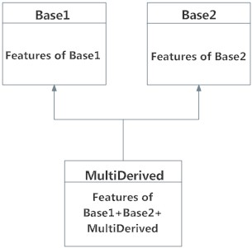
Multiple Inheritance in Python
The MultiDerived class inherits from both Base1 and Base2 classes.

Python Multilevel Inheritance
We can also inherit from a derived class. This is called multilevel inheritance. It can be of any depth in Python.
In multilevel inheritance, features of the base class and the derived class are inherited into the new derived class.
An example with corresponding visualization is given below.

class Base:
pass

class Derived1(Base):
pass

class Derived2(Derived1):
pass
Here, the Derived1 class is derived from the Base class, and the Derived2 class is derived from the Derived1 class.
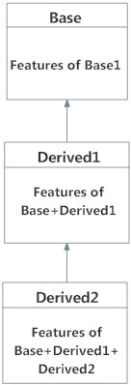
Multilevel Inheritance in Python

Method Overriding in Python
Method overriding is a concept of object oriented programming that allows us to change the implementation of a function in the child class that is defined in the parent class. It is the ability of a child class to change the implementation of any method which is already provided by one of its parent class(ancestors).
Following conditions must be met for overriding a function:
- Inheritance should be there. Function overriding cannot be done within a class. We need to derive a child class from a parent class.
- The function that is redefined in the child class should have the same signature as in the parent class i.e. same number of parameters.
# parent class
class Parent:
# some random function
def anything(self):
print('Function defined in parent class!')

# child class
class Child(Parent):
# empty class definition
pass

obj2 = Child()
obj2.anything()

OUTPUT

Function defined in parent class!

Python Special Functions
Class functions that begin with double underscore __ are called special functions in Python.
These functions are not the typical functions that we define for a class. The __init__() function we defined above is one of them. It gets called every time we create a new object of that class.
There are numerous other special functions in Python. Visit Python Special Functions to learn more about them.
Using special functions, we can make our class compatible with built-in functions.
>>> p1 = Point(2,3)
>>> print(p1)
<__main__.Point object at 0x00000000031F8CC0>
Suppose we want the print() function to print the coordinates of the Point object instead of what we got. We can define a __str__() method in our class that controls how the object gets printed. Let's look at how we can achieve this:
class Point:
def __init__(self, x = 0, y = 0):
self.x = x
self.y = y

def __str__(self):
return "({0},{1})".format(self.x,self.y)
Now let's try the print() function again.
class Point:
def __init__(self, x=0, y=0):
self.x = x
self.y = y

def __str__(self):
return "({0}, {1})".format(self.x, self.y)

p1 = Point(2, 3)
print(p1)
Output
(2, 3)
That's better. Turns out, that this same method is invoked when we use the built-in function str() or format().
>>> str(p1)
'(2,3)'

>>> format(p1)
'(2,3)'
So, when you use str(p1) or format(p1), Python internally calls the p1.__str__() method. Hence the name, special functions.

Polymorphism in Python

What is Polymorphism?
The literal meaning of polymorphism is the condition of occurrence in different forms.
Polymorphism is a very important concept in programming. It refers to the use of a single type entity (method, operator or object) to represent different types in different scenarios.
Let's take an example:

Example 1: Polymorphism in addition operator
We know that the + operator is used extensively in Python programs. But, it does not have a single usage.
For integer data types, + operator is used to perform arithmetic addition operation.
num1 = 1
num2 = 2
print(num1+num2)
Hence, the above program outputs 3.
Similarly, for string data types, + operator is used to perform concatenation.
str1 = "Python"
str2 = "Programming"
print(str1+" "+str2)
As a result, the above program outputs Python Programming.
Here, we can see that a single operator + has been used to carry out different operations for distinct data types. This is one of the most simple occurrences of polymorphism in Python

unction Polymorphism in Python
There are some functions in Python which are compatible to run with multiple data types.
One such function is the len() function. It can run with many data types in Python. Let's look at some example use cases of the function.

Example 2: Polymorphic len() function
print(len("Programiz"))
print(len(["Python", "Java", "C"]))
print(len({"Name": "John", "Address": "Nepal"}))
Output
9
3
2
Here, we can see that many data types such as string, list, tuple, set, and dictionary can work with the len() function. However, we can see that it returns specific information about specific data types.
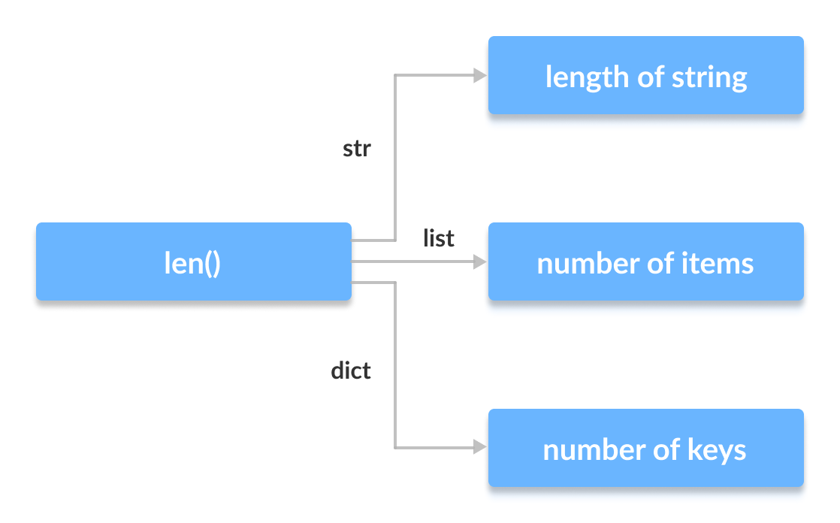Polymorphism in len() function in Python

Class Polymorphism in Python

Example 3: Polymorphism in Class Methods
class Cat:
def __init__(self, name, age):
self.name = name
self.age = age

def info(self):
print(f"I am a cat. My name is {self.name}. I am {self.age} years old.")

def make_sound(self):
print("Meow")

class Dog:
def __init__(self, name, age):
self.name = name
self.age = age

def info(self):
print(f"I am a dog. My name is {self.name}. I am {self.age} years old.")

def make_sound(self):
print("Bark")

cat1 = Cat("Kitty", 2.5)
dog1 = Dog("Fluffy", 4)

for animal in (cat1, dog1):
animal.make_sound()
animal.info()
animal.make_sound()
Output
Meow
I am a cat. My name is Kitty. I am 2.5 years old.
Meow
Bark
I am a dog. My name is Fluffy. I am 4 years old.
Bark
Here, we have created two classes Cat and Dog. They share a similar structure and have the same method names info() and make_sound().
However, notice that we have not created a common superclass or linked the classes together in any way. Even then, we can pack these two different objects into a tuple and iterate through it using a common animal variable. It is possible due to polymorphism.

