UNIT – 3
LANGUAGE COMPONENTS

Python Operators

Arithmetic operators
Arithmetic operators are used to perform mathematical operations like addition, subtraction, multiplication, etc.
Operator | Meaning | Example
+ | Add two operands or unary plus | x + y+ 2
- | Subtract right operand from the left or unary minus | x - y- 2
* | Multiply two operands | x * y
/ | Divide left operand by the right one (always results into float) | x / y
% | Modulus - remainder of the division of left operand by the right | x % y (remainder of x/y)
// | Floor division - division that results into whole number adjusted to the left in the number line | x // y
** | Exponent - left operand raised to the power of right | x**y (x to the power y)

Example 1: Arithmetic operators in Python
x = 15
y = 4

print('x + y =',x+y)

print('x - y =',x-y)

print('x * y =',x*y)

print('x / y =',x/y)

print('x // y =',x//y)

print('x ** y =',x**y)

Output
x + y = 19
x - y = 11
x * y = 60
x / y = 3.75
x // y = 3
x ** y = 50625
Comparison/Relational Operators
Comparison operators are used to compare values. It returns either True or False according to the condition.
Operator | Meaning | Example
> | Greater than - True if left operand is greater than the right | x > y
< | Less than - True if left operand is less than the right | x < y
== | Equal to - True if both operands are equal | x == y
!= | Not equal to - True if operands are not equal | x != y
>= | Greater than or equal to - True if left operand is greater than or equal to the right | x >= y
<= | Less than or equal to - True if left operand is less than or equal to the right | x <= y

Example 2: Comparison operators in Python
x = 10
y = 12

print('x > y is',x>y)

print('x < y is',x<y)

print('x == y is',x==y)

print('x != y is',x!=y)

print('x >= y is',x>=y)

print('x <= y is',x<=y)

Output

x > y is False
x < y is True
x == y is False
x != y is True
x >= y is False
x <= y is True

Logical operators

Logical operators are the and, or, not operators.
Operator | Meaning | Example
and | True if both the operands are true | x and y
or | True if either of the operands is true | x or y
not | True if operand is false (complements the operand) | not x

Example 3: Logical Operators in Python
x = True
y = False

print('x and y is',x and y)

print('x or y is',x or y)

print('not x is',not x)

Output
x and y is False
x or y is True
not x is False

Bitwise operators
Bitwise operators act on operands as if they were strings of binary digits. They operate bit by bit, hence the name.
For example, 2 is 10 in binary and 7 is 111.

Let x = 10 (00001010 in binary) and y = 4 (00000100 in binary)

The following table shows the result of various operations performed on operands x and y

Operator | Meaning | Example
& | Bitwise AND | x & y = 0 (0000 0000)
| | Bitwise OR | x | y = 14 (0000 1110)
~ | Bitwise NOT | ~x = -11 (1111 0101)
^ | Bitwise XOR | x ^ y = 14 (0000 1110)
>> | Bitwise right shift | x >> 2 = 2 (0000 0010)
<< | Bitwise left shift | x << 2 = 40 (0010 1000)

Assignment operators

Assignment operators are used in Python to assign values to variables.

a=5 is a simple assignment operator that assigns the value 5 on the right to the variable ‘a’ on the left.

There are various compound operators in Python like a += 5 that adds to the variable and later assigns the same. It is equivalent to a = a + 5.
Operator | Example | Equivalent to
= | x = 5 | x = 5
+= | x += 5 | x = x + 5
-= | x -= 5 | x = x - 5
*= | x *= 5 | x = x * 5
/= | x /= 5 | x = x / 5
%= | x %= 5 | x = x % 5
//= | x //= 5 | x = x // 5
**= | x **= 5 | x = x ** 5
&= | x &= 5 | x = x & 5
|= | x |= 5 | x = x | 5
^= | x ^= 5 | x = x ^ 5
>>= | x >>= 5 | x = x >> 5
<<= | x <<= 5 | x = x << 5
Special operators
Python language offers some special types of operators like the identity operator or the membership operator. They are described below with examples.
Identity operators
is and is not are the identity operators in Python. They are used to check if two values (or variables) are located on the same part of the memory. Two variables that are equal does not imply that they are identical.
Operator | Meaning | Example
is | True if the operands are identical (refer to the same object) | x is True
is not | True if the operands are not identical (do not refer to the same object) | x is not True

Example 4: Identity operators in Python
x1 = 5
y1 = 5
x2 = 'Hello'
y2 = 'Hello'
x3 = [1,2,3]
y3 = [1,2,3]

print(x1 is not y1)

print(x2 is y2)

print(x3 is y3)

Output
False
True
False

Membership operators
in and not in are the membership operators in Python. They are used to test whether a value or variable is found in a sequence (string, list, tuple, set and dictionary).
In a dictionary we can only test for presence of key, not the value.
Operator | Meaning | Example
in | True if value/variable is found in the sequence | 5 in x
not in | True if value/variable is not found in the sequence | 5 not in x
Example #5: Membership operators in Python
x = 'Hello world'
y = {1 : 'a' ,2 : 'b'}

print('H' in x)

print('hello' not in x)

print(1 in y)

print('a' in y)

Output

True
True
True
False

Python if else

There comes situations in real life when we need to make some decisions and based on these decisions, we decide what should we do next. Similar situations arises in programming also where we need to make some decisions and based on these decisions we will execute the next block of code.

Decision making statements in programming languages decides the direction of flow of program execution. Decision making statements available in python are:

if statement

if statement is the most simple decision making statement. It is used to decide whether a certain statement or block of statements will be executed or not i.e if a certain condition is true then a block of statement is executed otherwise not.
Syntax:
if test expression:
statement(s)
Here, condition after evaluation will be either true or false. if statement accepts boolean values – if the value is true then it will execute the block of statements below it otherwise not.

Python if Statement Flowchart
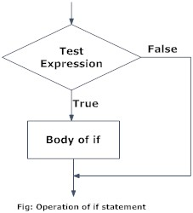

Example: Python if Statement
# python program to illustrate If statement

i = 10
if (i > 15):
print ("10 is less than 15")
print ("I am Not in if")

Output:
I am Not in if
As the condition present in the if statement is false. So, the block below the if statement
is not executed.

if- else

The if statement alone tells us that if a condition is true it will execute a block of statements and if the condition is false it won’t. But what if we want to do something else if the condition is false. Here comes the else statement. We can use the else statement with if statement to execute a block of code when the condition is false.
Syntax:
if (condition):
# Executes this block if
# condition is true
else:
# Executes this block if
# condition is false
Flow Chart:-
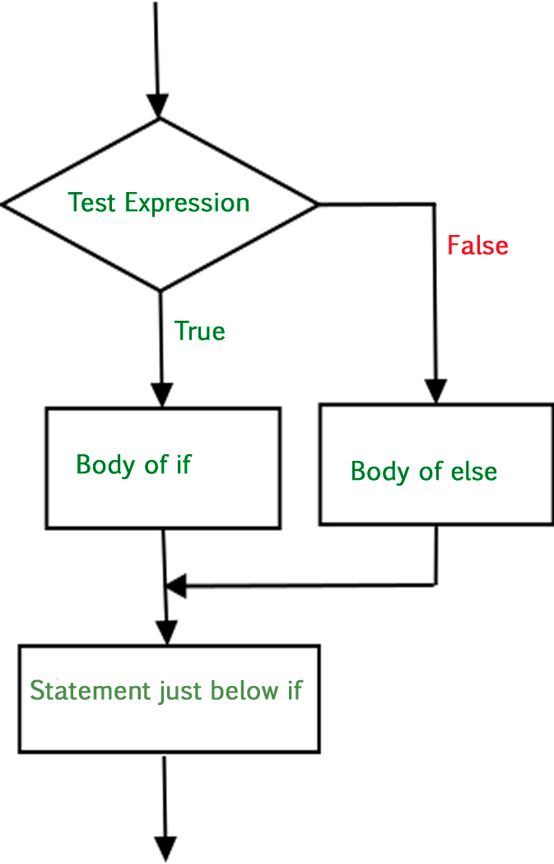
# python program to illustrate If else statement

i = 20;
if (i < 15):
print ("i is smaller than 15")
print ("i'm in if Block")
else:
print ("i is greater than 15")
print ("i'm in else Block")
print ("i'm not in if and not in else Block")

Output:
i is greater than 15
i'm in else Block
i'm not in if and not in else Block

The block of code following the else statement is executed as the condition present in the if statement is false.

nested-if

A nested if is an if statement that is the target of another if statement. Nested if statements means an if statement inside another if statement. Yes, Python allows us to nest if statements within if statements. i.e, we can place an if statement inside another if statement.

Syntax:
if (condition1):
# Executes when condition1 is true
if (condition2):
# Executes when condition2 is true
# if Block is end here
# if Block is end here
Flow chart:-
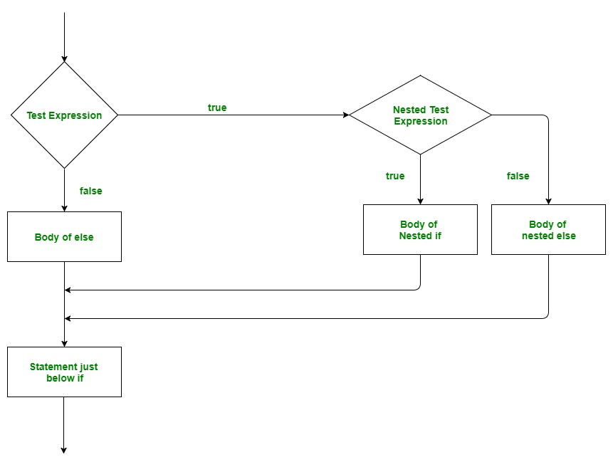

# python program to illustrate nested If statement
i = 10
if (i == 10):
# First if statement
if (i < 15):
print ("i is smaller than 15")
# Nested - if statement
# Will only be executed if statement above
# it is true
if (i < 12):
print ("i is smaller than 12 too")
else:
print ("i is greater than 15")
Output:
i is smaller than 15
i is smaller than 12 too

Indentation

Python relies on indentation (whitespace at the beginning of a line) to define scope in the code. Other programming languages often use curly-brackets for this purpose.

Example
If statement, without indentation (will raise an error):

a= 33
b= 200
if b > a:

print("b is greater than a") # you will get an error

Python Loops

Loops are used in programming to repeat a specific block of code. In this article, you will learn to create a while loop in Python.
Python has two loop commands:
- while loops
- for loops

The while Loop
With the while loop we can execute a set of statements as long as a condition is true. We generally use this loop when we don't know the number of times to iterate beforehand.

Syntax of while Loop in Python
while test_expression:
statement(s)
In the while loop, test expression is checked first. The body of the loop is entered only if the test_expression evaluates to True. After one iteration, the test expression is checked again. This process continues until the test_expression evaluates to False.
In Python, the body of the while loop is determined through indentation.
The body starts with indentation and the first unindented line marks the end.

Flowchart of while Loop
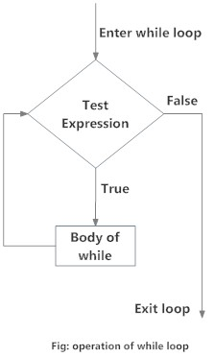

Example: Python while Loop
# Python program to illustrate
# while loop
count = 0
while (count < 3):
count = count + 1
print("Hello Python")

Output
Hello Python
Hello Python
Hello Python

Loop Control Statements
Loop control statements change execution from its normal sequence. When execution leaves a scope, all automatic objects that were created in that scope are destroyed. Python supports the following control statements.

Continue Statement: It returns the control to the beginning of the loop.

# Prints all letters except 'A' and 'B'
i = 0
a = 'GPAMBALA'

while i < len(a):
if a[i] == 'A' or a[i] == 'B':
i += 1
continue
print('Current Letter :', a[i])
i += 1

Output
Current Letter : G
Current Letter : P
Current Letter : M
Current Letter : L

Break Statement: It brings control out of the loop

# Prints all letters except 'A' and 'B'
i = 0
a = 'GPAMBALA'

while i < len(a):
if a[i] == 'A' or a[i] == 'B':
i += 1
break
print('Current Letter :', a[i])
i += 1

OUTPUT
Current Letter : G
Current Letter : P

Python For Loops
A for loop is used for iterating over a sequence (that is either a list, a tuple, a dictionary, a set, or a string). With the for loop we can execute a set of statements, once for each item in a list, tuple, set etc.

For in loops
There is “for in” loop which is similar to for each loop in other languages. Let us learn how to use for in loop for sequential traversals.

Syntax:

for var in iterable:
# statements

Example: Python for Loop
# Program to find the sum of all numbers stored in a list

# List of numbers
numbers = [6, 5, 3, 8, 4, 2, 5, 4, 11]

# variable to store the sum
sum = 0

# iterate over the list
for val in numbers:
sum = sum+val

print("The sum is", sum)
When you run the program, the output will be:
The sum is 48

The range() function
We can generate a sequence of numbers using range() function. range(10) will generate numbers from 0 to 9 (10 numbers).
We can also define the start, stop and step size as range(start, stop,step_size). step_size defaults to 1 if not provided..
This function does not store all the values in memory; it would be inefficient. So it remembers the start, stop, step size and generates the next number on the go.
To force this function to output all the items, we can use the function list().
The following example will clarify this.
print(range(10))

print(list(range(10)))

print(list(range(2, 8)))

print(list(range(2, 20, 3)))
Output
range(0, 10)
[0, 1, 2, 3, 4, 5, 6, 7, 8, 9]
[2, 3, 4, 5, 6, 7]
[2, 5, 8, 11, 14, 17]
We can use the range() function in for loops to iterate through a sequence of numbers. It can be combined with the len() function to iterate through a sequence using indexing. Here is an example.
# Program to iterate through a list using indexing

genre = ['pop', 'rock', 'jazz']

# iterate over the list using index
for i in range(len(genre)):
print("I like", genre[i])
Output
I like pop
I like rock
​I like jazz

