UNIT-1
PYTHON

Introduction
Python is a widely used general-purpose, high level programming language. It was created by Guido van Rossum in 1991 and further developed by the Python Software Foundation. It was designed with an emphasis on code readability, and its syntax allows programmers to express their concepts in fewer lines of code.
Features of Python

Python Features
Python's features include −
- Easy-to-learn − Python has few keywords, simple structure, and a clearly defined syntax. This allows the student to pick up the language quickly.
- Easy-to-read − Python code is more clearly defined and visible to the eyes.
- Easy-to-maintain − Python's source code is fairly easy-to-maintain.
- A broad standard library − Python's bulk of the library is very portable and cross-platform compatible on UNIX, Windows, and Macintosh.
- Interactive Mode − Python has support for an interactive mode which allows interactive testing and debugging of snippets of code.
- Portable − Python can run on a wide variety of hardware platforms and has the same interface on all platforms.
- Extendable − You can add low-level modules to the Python interpreter. These modules enable programmers to add to or customize their tools to be more efficient.
- Databases − Python provides interfaces to all major commercial databases.
- GUI Programming − Python supports GUI applications that can be created and ported to many system calls, libraries and windows systems, such as Windows MFC, Macintosh, and the X Window system of Unix.
- Scalable − Python provides a better structure and support for large programs than shell scripting.

Installing Pyhton
Python is available on a wide variety of platforms including Linux and Mac OS X. Let's understand how to set up our Python environment.

Getting Python
The most up-to-date and current source code, binaries, documentation, news, etc., is available on the official website of Python https://www.python.org/
You can download Python documentation from https://www.python.org/doc/. The documentation is available in HTML, PDF, and PostScript formats.

Installing Python
Python distribution is available for a wide variety of platforms. You need to download only the binary code applicable for your platform and install Python.
If the binary code for your platform is not available, you need a C compiler to compile the source code manually. Compiling the source code offers more flexibility in terms of choice of features that you require in your installation.
Here is a quick overview of installing Python on windows platform –
Here are the steps to install Python on Windows machine.
- Open a Web browser and go to https://www.python.org/downloads/.
- Follow the link for the Windows installer python-XYZ.msi file where XYZ is the version you need to install.
- Save the installer file to your local machine.
- Run the downloaded file. This brings up the Python install wizard, which is really easy to use. Just accept the default settings, wait until the install is finished, and you are done.

Python Environment Variables
Here are important environment variables, which can be recognized by Python −
Sr.No. | Variable & Description
1 | PYTHONPATH  It has a role similar to PATH. This variable tells the Python interpreter where to locate the module files imported into a program. PYTHONPATH is sometimes preset by the Python installer.
2 | PYTHONSTARTUP  It contains the path of an initialization file containing Python source code. It is executed every time you start the interpreter.
3 | PYTHONCASEOK  It is used in Windows to instruct Python to find the first case-insensitive match in an import statement. Set this variable to any value to activate it.
4 | PYTHONHOME  It is an alternative module search path. It is usually embedded in the PYTHONSTARTUP or PYTHONPATH directories to make switching module libraries easy.

Executing Python from command line

A Python interactive session will allow you to write a lot of lines of code, but once you close the session, you lose everything you’ve written. That’s why the usual way of writing Python programs is by using plain text files. By convention, those files will use the .py extension.
Python code files can be created with any plain text editor. If you are new to Python programming, you can try Notepad, which is a powerful and easy-to-use editor, but you can use any editor you like.
To keep moving forward in this tutorial, you’ll need to create a test script. Open your favorite text editor and write the following code:

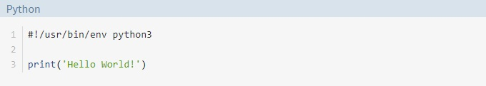

Save the file in your working directory with the name hello.py. With the test script ready, you can continue reading.

Using the python Command

To run Python scripts with the python command, you need to open a command-line and type in the word python, or python3 if you have both versions, followed by the path to your script, just like this:
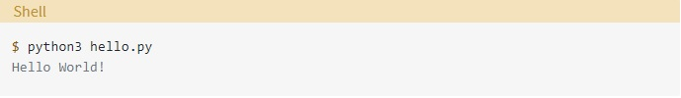
If everything works okay, after you press Enter, you’ll see the phrase Hello World! on your screen. That’s it! You’ve just run your first Python script!
If this doesn’t work right, maybe you’ll need to check your system PATH, your Python installation, the way you created the hello.py script, the place where you saved it, and so on.
IDLE
Every Python installation comes with an Integrated Development and Learning Environment, which you’ll see shortened to IDLE. These are a class of applications that help you write code more efficiently.
Python IDLE comes included in Python installations on Windows and Mac. If you’re a Linux user, then you should be able to find and download Python IDLE using your package manager. Once you’ve installed it, you can then use Python IDLE as an interactive interpreter or as a file editor.

A File Editor
Every programmer needs to be able to edit and save text files. Python programs are files with the .py extension that contain lines of Python code. Python IDLE gives you the ability to create and edit these files with ease.
Python IDLE also provides several useful features that you’ll see in professional IDEs, like basic syntax highlighting, code completion, and auto-indentation. Professional IDEs are more robust pieces of software and they have a steep learning curve. If you’re just beginning your Python programming journey, then Python IDLE is a great alternative!

How to Use the Python IDLE Shell
The shell is the default mode of operation for Python IDLE. When you click on the icon to open the program, the shell is the first thing that you see:
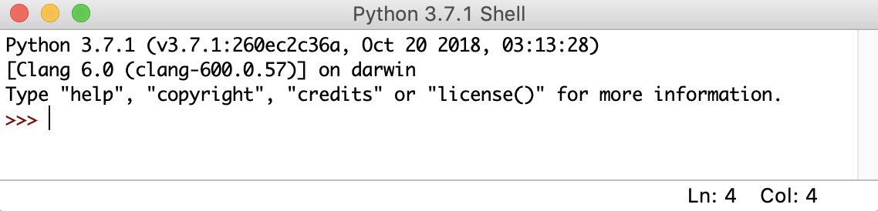
This is a blank Python interpreter window. You can use it to start interacting with Python immediately. You can test it out with a short line of code:
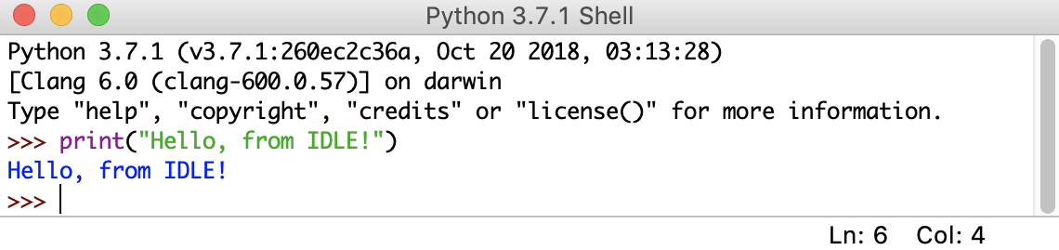
Here, you used print() to output the string "Hello, from IDLE!" to your screen. This is the most basic way to interact with Python IDLE. You type in commands one at a time and Python responds with the result of each command.

How to Work With Python Files
Python IDLE offers a full-fledged file editor, which gives you the ability to write and execute Python programs from within this program. The built-in file editor also includes several features, like code completion and automatic indentation, that will speed up your coding workflow. First, let’s take a look at how to write and execute programs in Python IDLE.

Opening a File
To start a new Python file, select File → New File from the menu bar. This will open a blank file in the editor, like this:
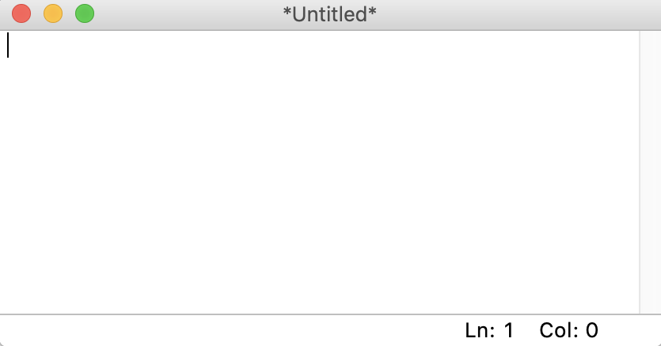
From this window, you can write a brand new Python file. You can also open an existing Python file by selecting File → Open… in the menu bar. This will bring up your operating system’s file browser. Then, you can find the Python file you want to open.
If you’re interested in reading the source code for a Python module, then you can select File → Path Browser. This will let you view the modules that Python IDLE can see. When you double click on one, the file editor will open up and you’ll be able to read it.

Editing a File
Once you’ve opened a file in Python IDLE, you can then make changes to it. When you’re ready to edit a file, you’ll see something like this:
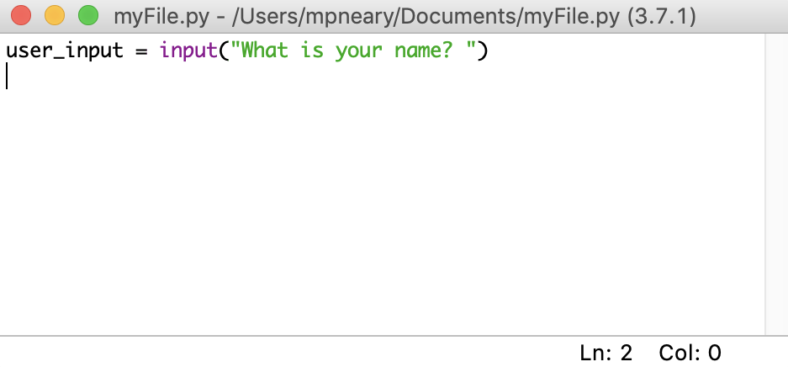
The contents of your file are displayed in the open window. The bar along the top of the window contains three pieces of important information:
- The name of the file that you’re editing
- The full path to the folder where you can find this file on your computer
- The version of Python that IDLE is using
In the image above, you’re editing the file myFile.py, which is located in the Documents folder. The Python version is 3.7.1, which you can see in parentheses.
There are also two numbers in the bottom right corner of the window:
- Ln: shows the line number that your cursor is on.
- Col: shows the column number that your cursor is on.
It’s useful to see these numbers so that you can find errors more quickly. They also help you make sure that you’re staying within a certain line width.
There are a few visual cues in this window that will help you remember to save your work. If you look closely, then you’ll see that Python IDLE uses asterisks to let you know that your file has unsaved changes:
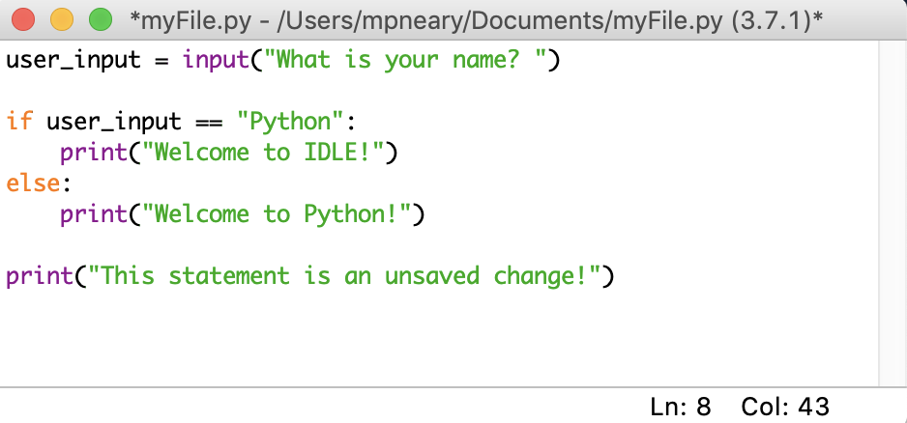
The file name shown in the top of the IDLE window is surrounded by asterisks. This means that there are unsaved changes in your editor. You can save these changes with your system’s standard keyboard shortcut, or you can select File → Save from the menu bar. Make sure that you save your file with the .py extension so that syntax highlighting will be enabled.
Python Documentation and Getting help
You can access Python Documentation from IDLE by clicking of Help Menu and select python docs option and by just pressing F1 key on the keyboard
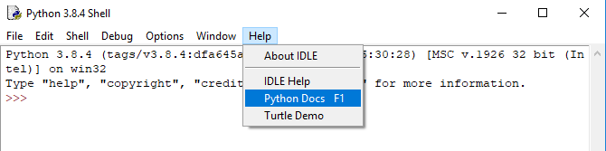
The following windows appears on the screen
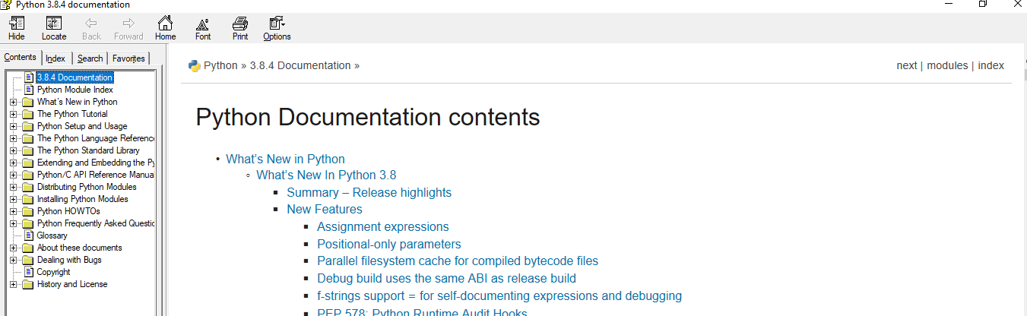

Python documentation helps you to correct syntax as it shows the examples of various python scripts to explain various topics in Python.
Python Dynamic Types
Python is a dynamically typed language. What is dynamic? We don't have to declare the type of a variable or manage the memory while assigning a value to a variable in Python. Other languages like C, C++, Java, etc.., there is a strict declaration of variables before assigning values to them. We have to declare the kind of variable before assigning a value to it in the languages C, C++, Java, etc..,
Python don't have any problem even if we don't declare the type of variable. It states the kind of variable in the runtime of the program. Python also take cares of the memory management which is crucial in programming. So, Python is a dynamically typed language. Let's see one example.

Example
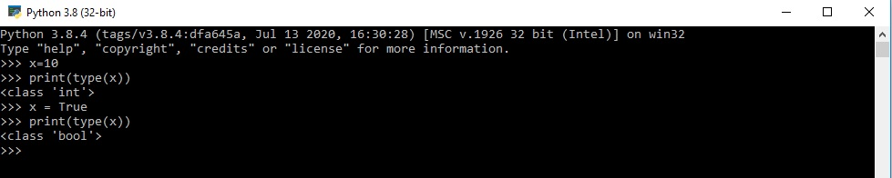
As you see, we didn't declare the type of variable in the program. Python will automatically recognize the type of variable with the help of the value in the runtime.

Python Reserved Words
Python has a set of keywords that are reserved words that cannot be used as variable names, function names, or any other identifiers:
Python
Keywords
False | def | if | raise
None | del | import | return
True | elif | in | try
and | else | is | while
as | except | lambda | with
assert | finally | nonlocal | yield
break | for | not
class | from | or
continue | global | pass

You can see this list any time by typing help("keywords") to the Python interpreter. Reserved words are case-sensitive and must be used exactly as shown. They are all entirely lowercase, except for False, None, and True.
Naming Conventions
When you write Python code, you have to name a lot of things: variables, functions, classes, packages, and so on. Choosing sensible names will save you time and energy later. You’ll be able to figure out, from the name, what a certain variable, function, or class represents. You’ll also avoid using inappropriate names that might result in errors that are difficult to debug.

1. General
- Avoid using names that are too general or too wordy. Strike a good balance between the two.
- Bad: data_structure, my_list, info_map, dictionary_for_the_purpose_of_storing_data_representing_word_definitions
- Good: user_profile, menu_options, word_definitions
- Don’t be a jackass and name things “O”, “l”, or “I”
- When using CamelCase names, capitalize all letters of an abbreviation (e.g. HTTPServer)

2. Packages
- Package names should be all lower case
- When multiple words are needed, an underscore should separate them
- It is usually preferable to stick to 1 word names

3. Modules
- Module names should be all lower case
- When multiple words are needed, an underscore should separate them
- It is usually preferable to stick to 1 word names

4. Classes
- Class names should follow the UpperCaseCamelCase convention
- Python’s built-in classes, however are typically lowercase words
- Exception classes should end in “Error”

5. Global (module-level) Variables
- Global variables should be all lowercase
- Words in a global variable name should be separated by an underscore

6. Instance Variables
- Instance variable names should be all lower case
- Words in an instance variable name should be separated by an underscore
- Non-public instance variables should begin with a single underscore
- If an instance name needs to be mangled, two underscores may begin its name

7. Methods
- Method names should be all lower case
- Words in an method name should be separated by an underscore
- Non-public method should begin with a single underscore
- If a method name needs to be mangled, two underscores may begin its name

8. Method Arguments
- Instance methods should have their first argument named ‘self’.
- Class methods should have their first argument named ‘cls’

9. Functions
- Function names should be all lower case
- Words in a function name should be separated by an underscore

10. Constants
- Constant names must be fully capitalized
- Words in a constant name should be separated by an underscore

